- Write a JavaScript program to display the current day and time in the following format
Sample Output : Today is : Friday.
Current time is : 4 PM : 50 : 22
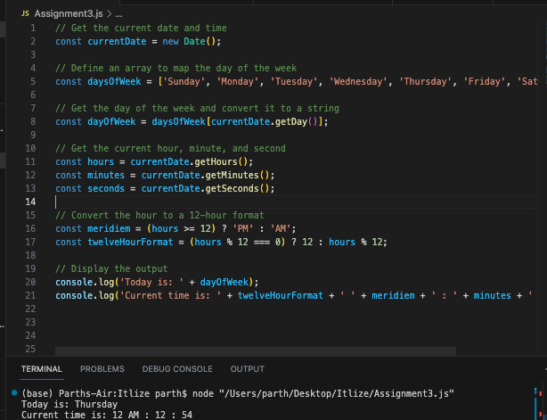
- Write a JavaScript program to get the current date.
Expected Output :
mm-dd-yyyy, mm/dd/yyyy or dd-mm-yyyy, dd/mm/yyyy
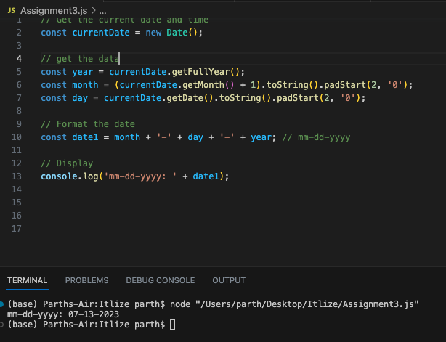

- Write a JavaScript program to calculate multiplication and division of two numbers (input from user).
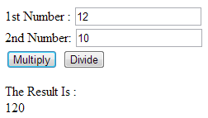
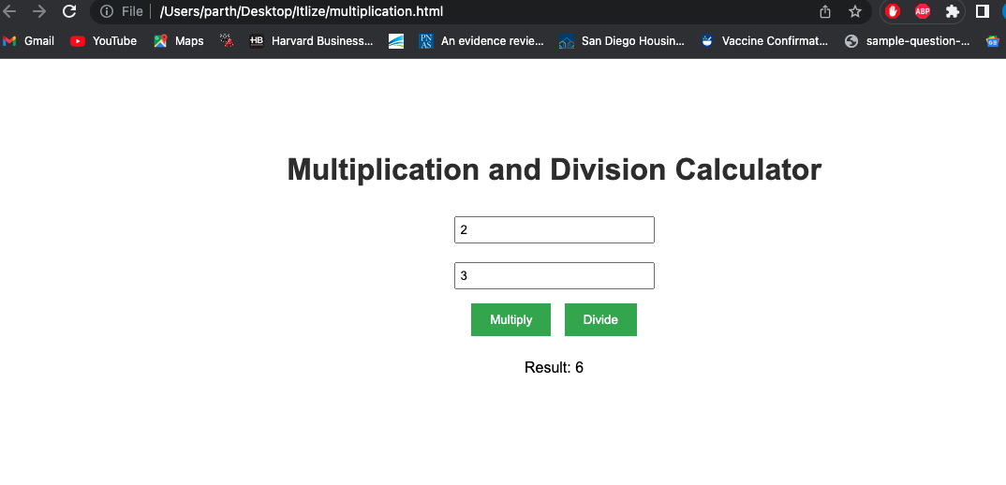
Code for Question 3:
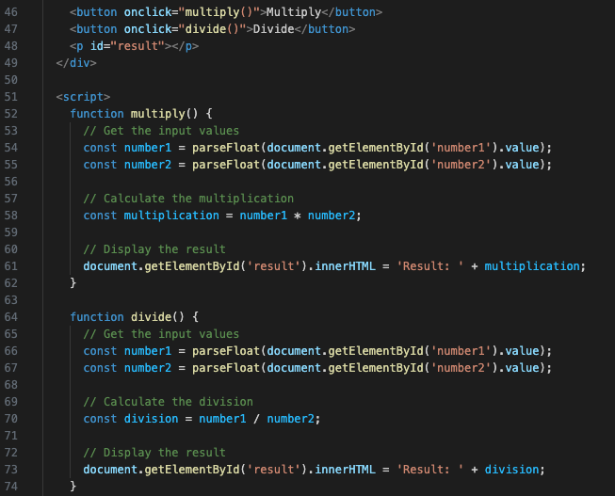
- Write a JavaScript program to get the website URL (loading page)
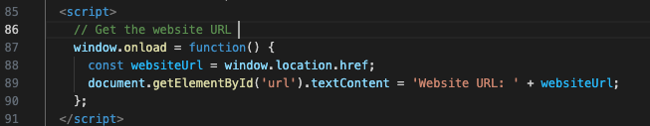

- Write a JavaScript function that reverse a number
Example x = 32243;
Expected Output : 34223
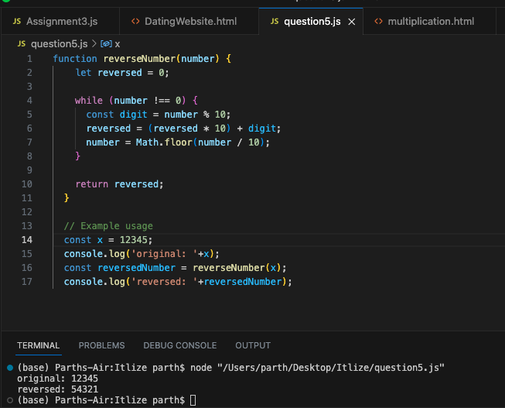

- Write a JavaScript function which will take an array of numbers stored and find the second lowest and second greatest numbers, respectively.
Sample array : [1,2,3,4,5]
Expected Output : 2,4

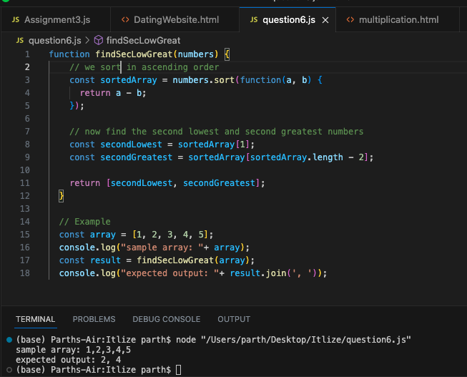

- Write a JavaScript program to get the integers in range (x, y). Go to the editor
Example : range(2, 9)
Expected Output : [3, 4, 5, 6, 7, 8]
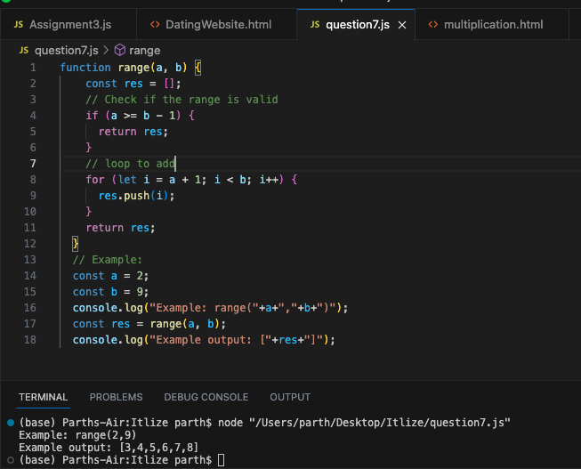

- Write a merge sort program in JavaScript.
Sample array : [34,7,23,32,5,62]
Sample output : [5, 7, 23, 32, 34, 62]
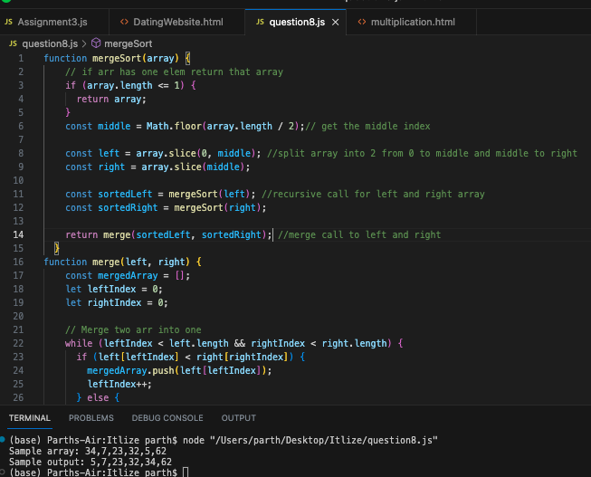
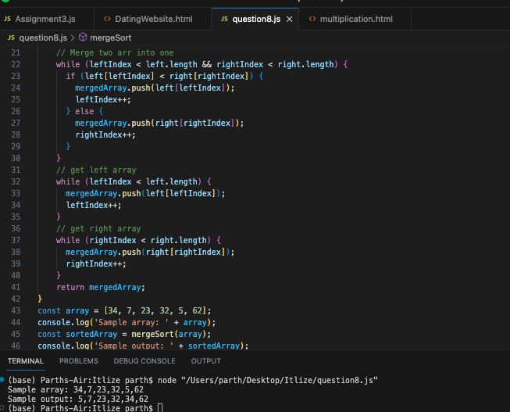
- Write a JavaScript conditional statement to find the largest of five numbers. Display an alert box to show the result.
Sample numbers : -5, -2, -6, 0, -1
Output : 0
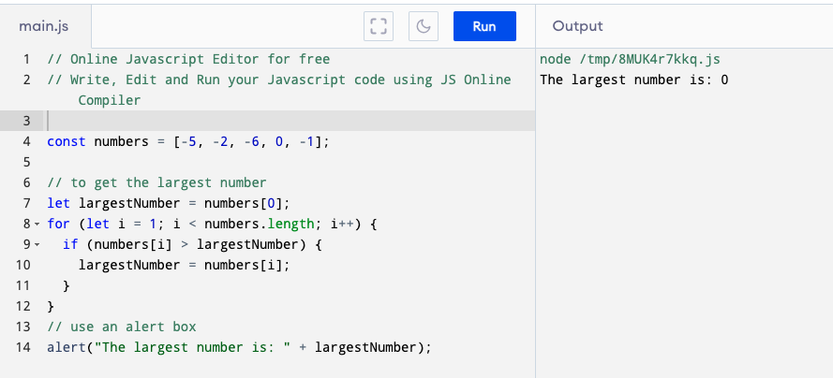

- Write a JavaScript function to validate whether a given value type is NaN or not.
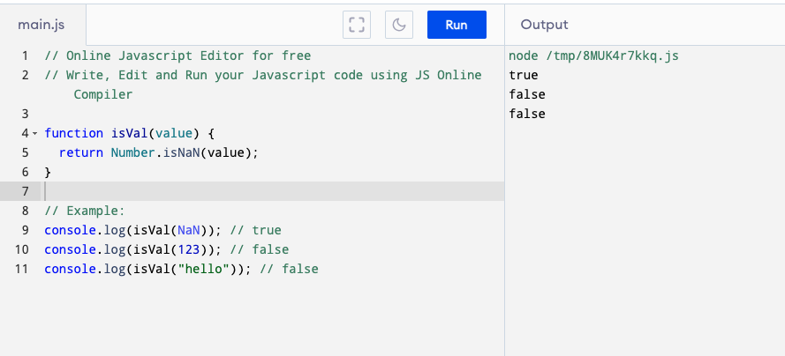

- Write a JavaScript function to check whether given value types are same or not.
